**Disha Vadecha**

**182011046**

**E-Commerce Website (Bouquet Management)**

You start with the basic index.php



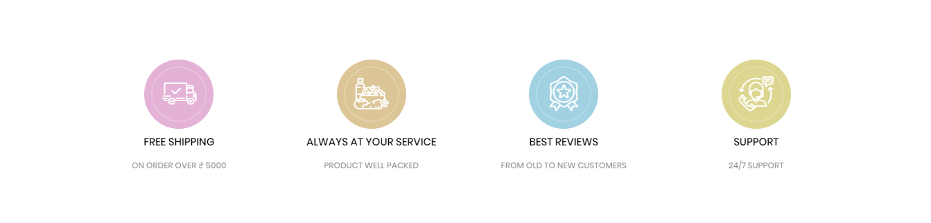

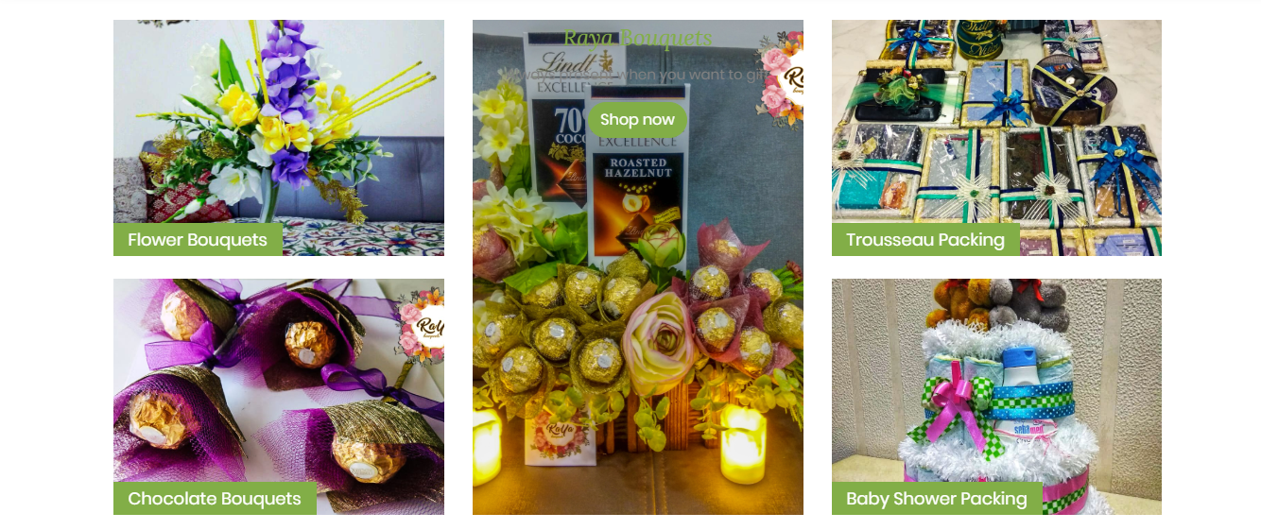

A user needs to register via register.php

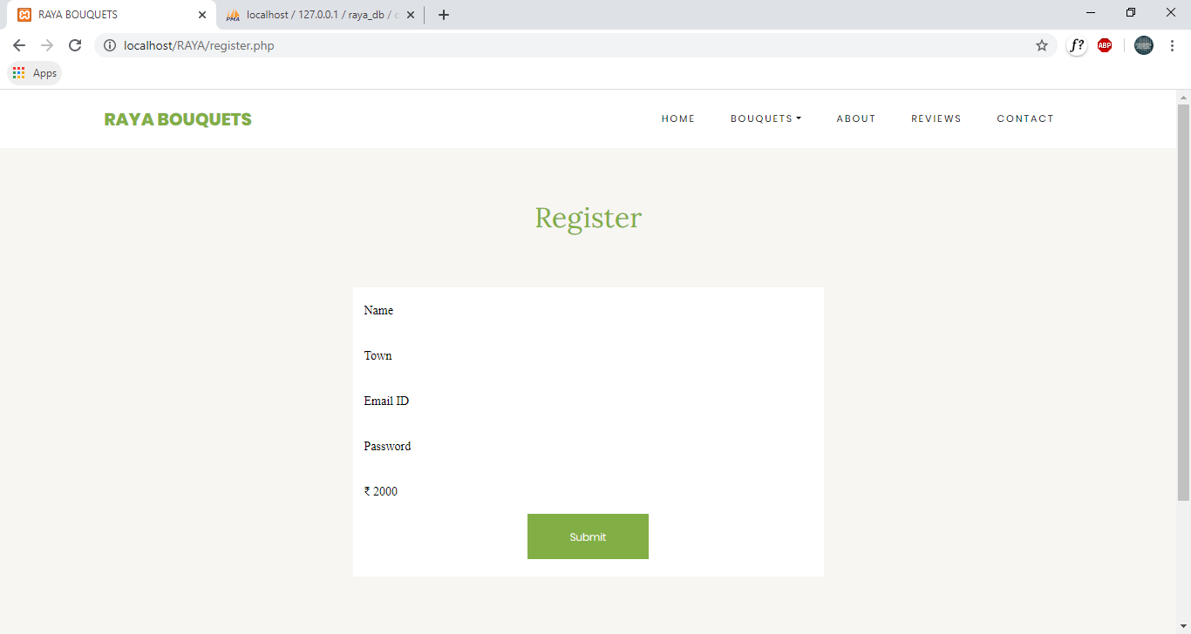

After Registering, if a user wants to browse the website, they have to login via the login.php

There are 2 kinds of user: Normal user and Admin

*Normal User Functionalities:*

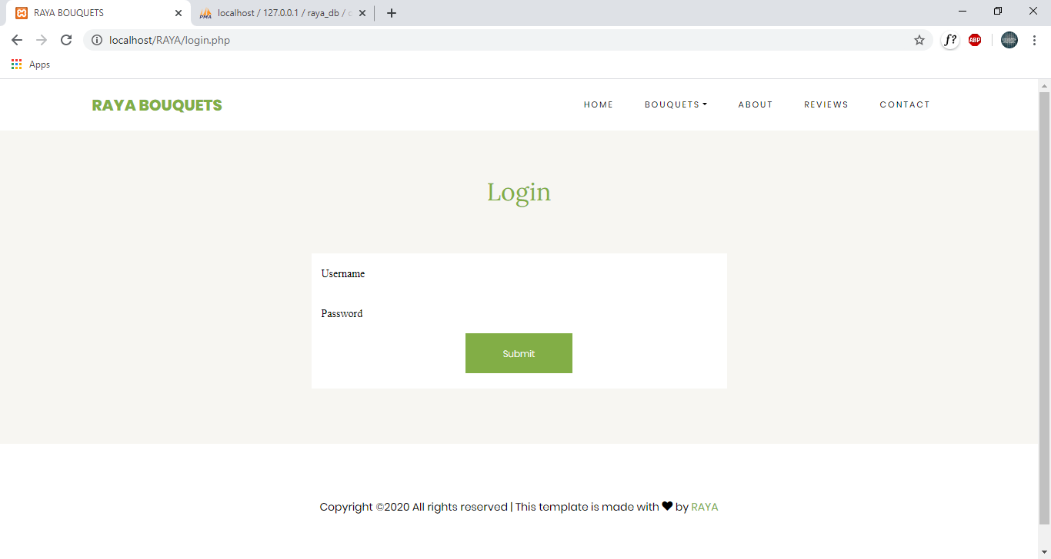

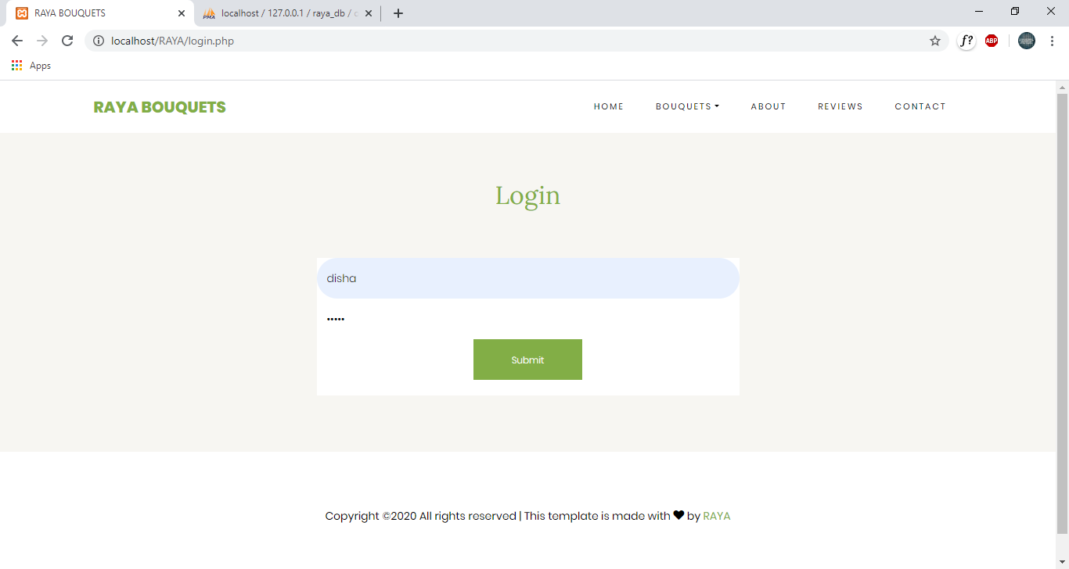

Once logged in, the header for user changes to this.



Now, they can access any page out of the all product pages



If a person wants to buy a product, they must go to the cart symbol on the top of the page. This will lead them to cartcheck.php.

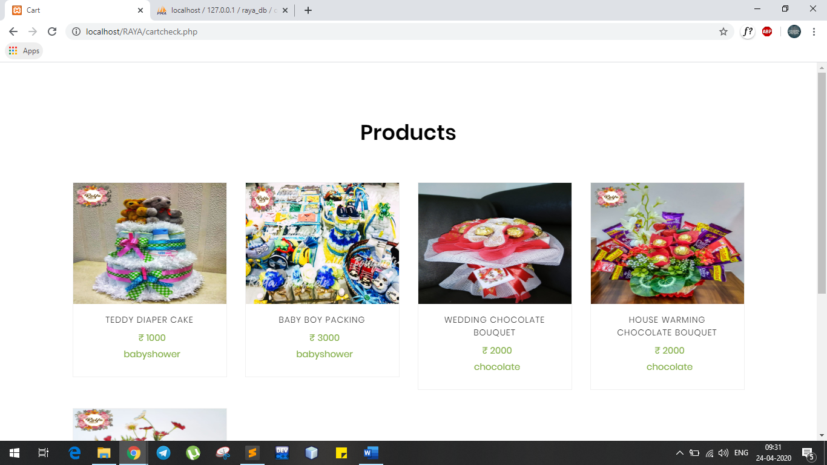

On hover of a product, a buy now button appears, on clicking that button, the cart is formed.

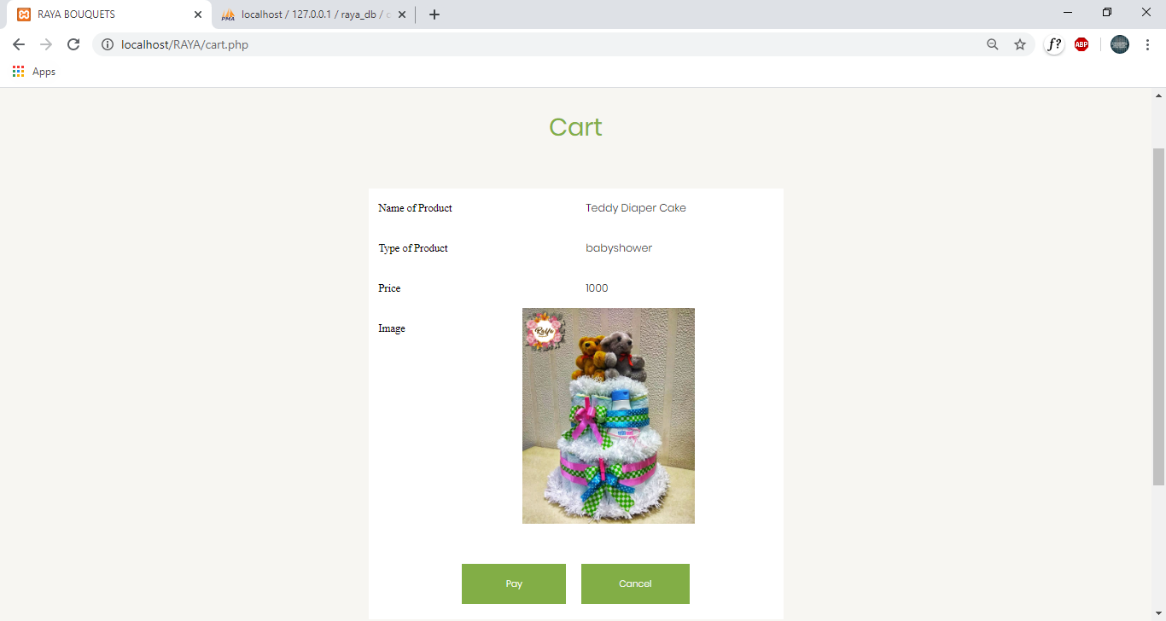

On Clicking on pay, you will be redirected to index page.

Backend changes

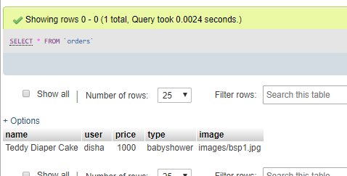

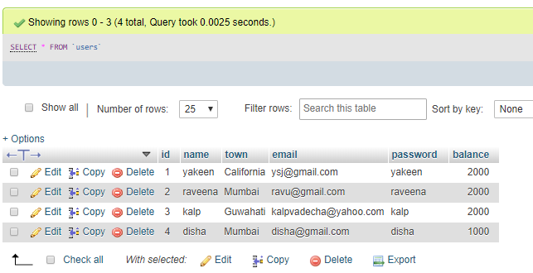

*Admin Functionalities:*

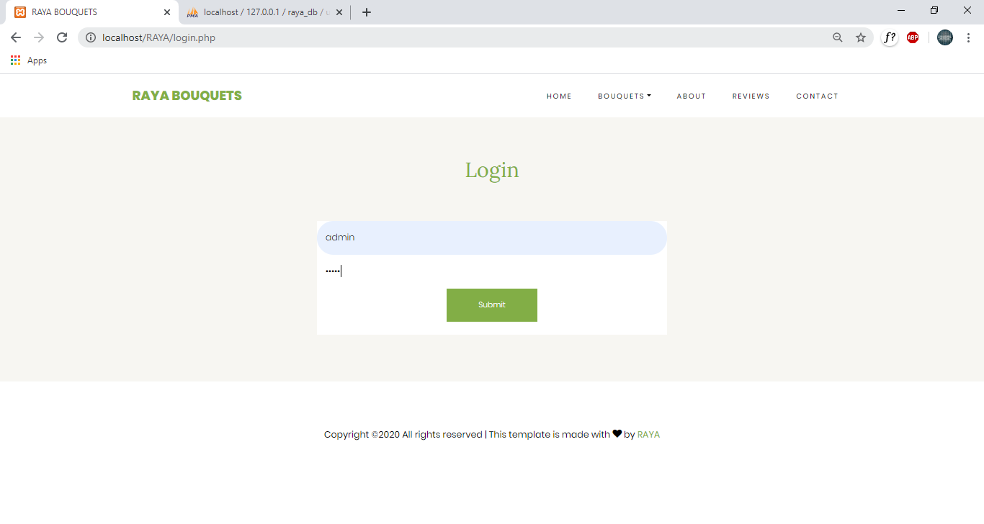

A new list item “ADD ITEM” is added in the header of the admin

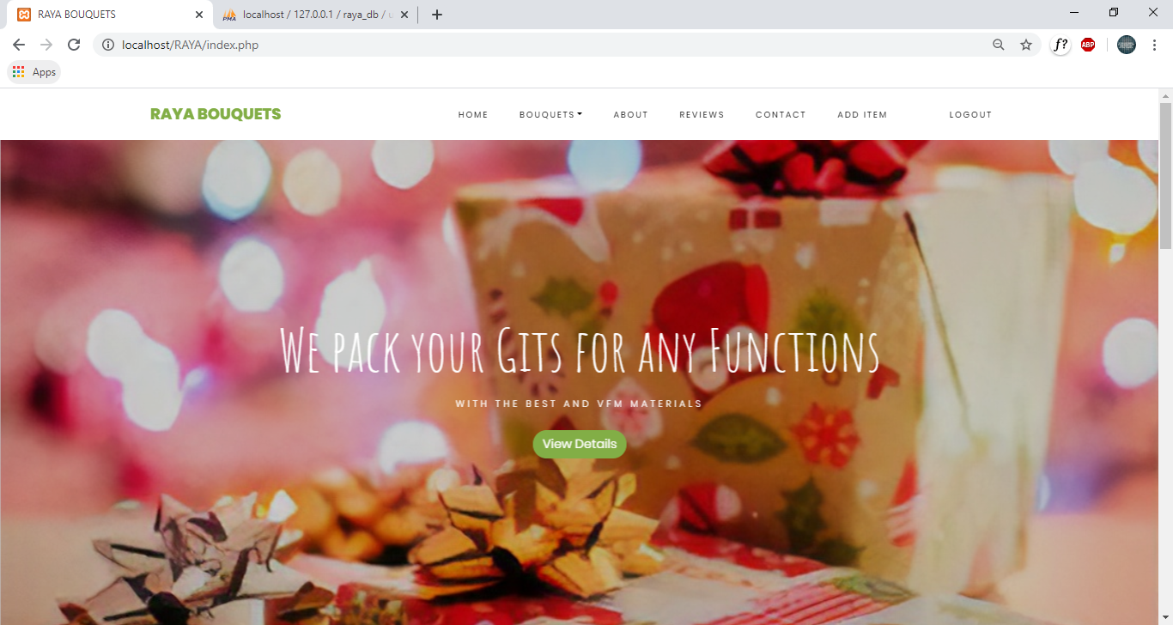

The additem.php looks like this.

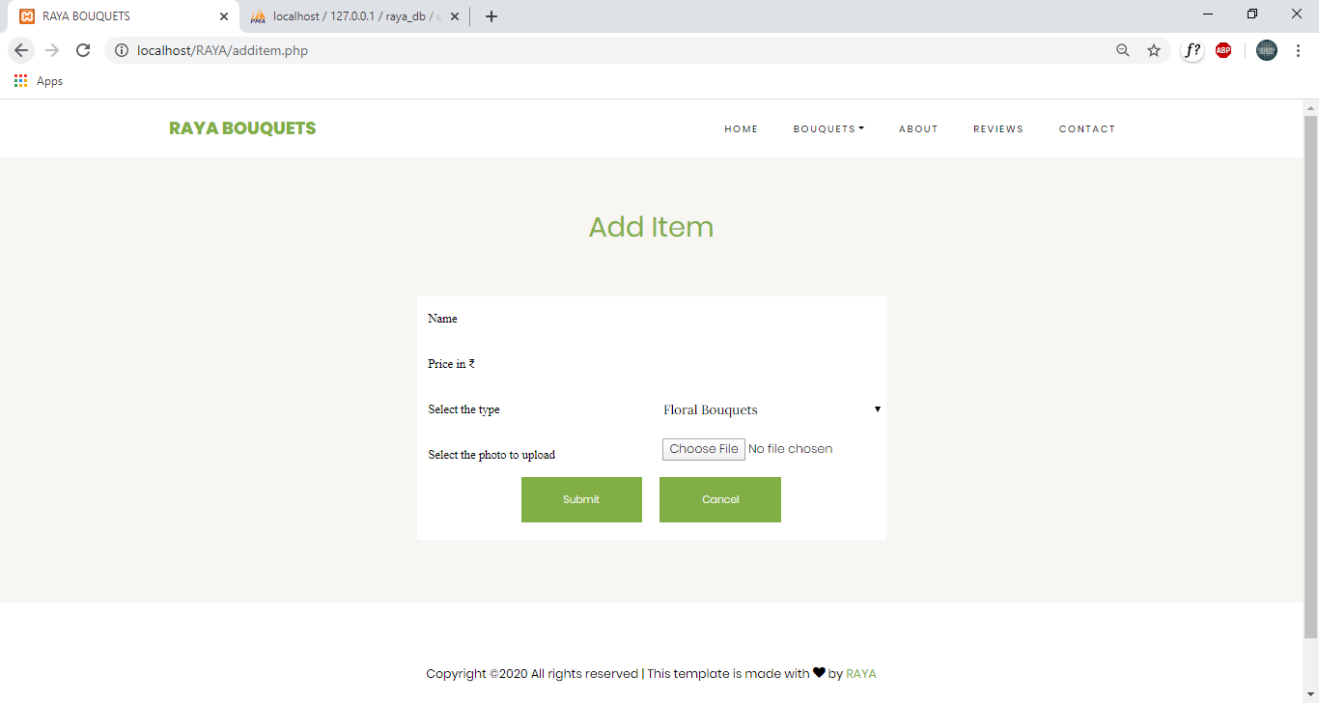

Suppose the admin wants to add a trousseau packing item.

He will first select the product from the folder.

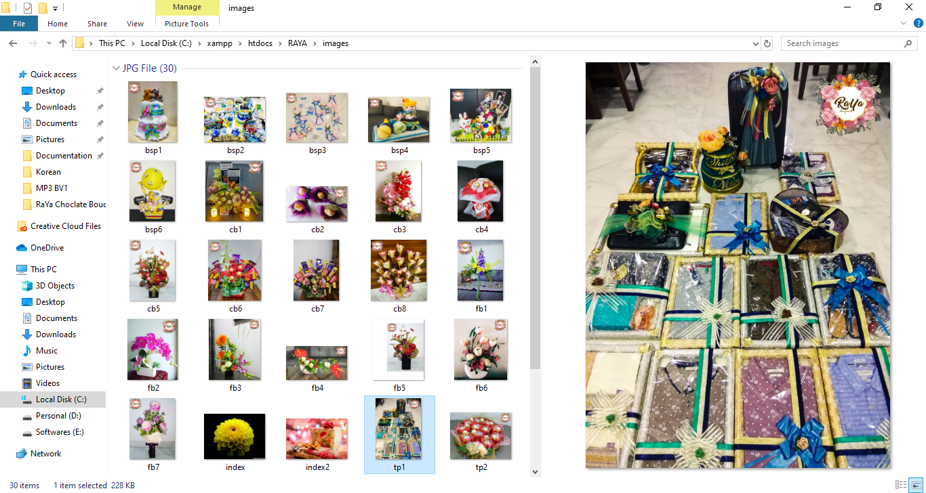

He will fill details in the additem.php page

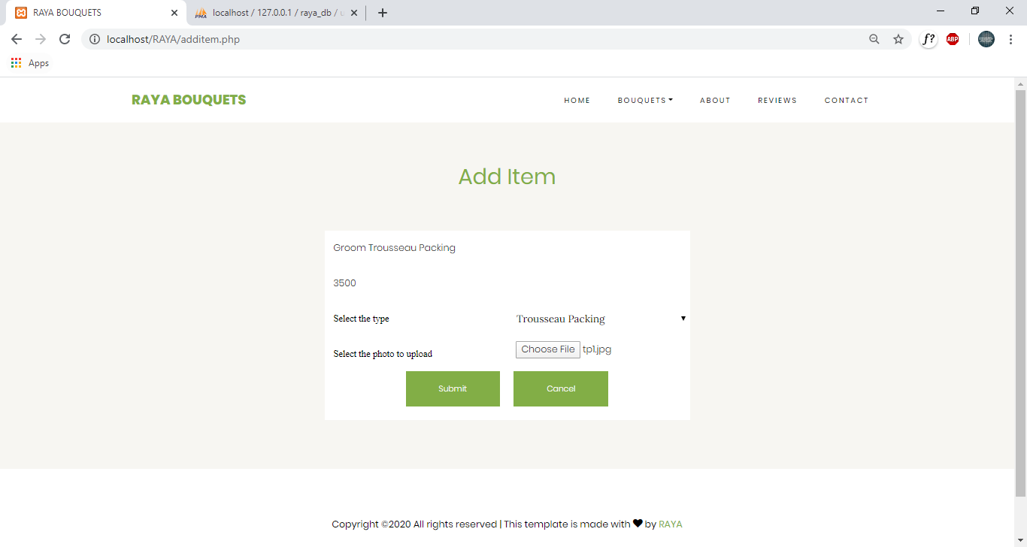

On Submitting it, the entry is made in the database.

